It would be helpful if the following features were available for the dashboards overview screen (and maybe all overview screens(

Resize number of tiles per row
When resizing the screen (zoom in, zoom out) always 4 are placed on 1 row. But on larger screen sizes, there is room to use the available space for more tiles. See the the image below.
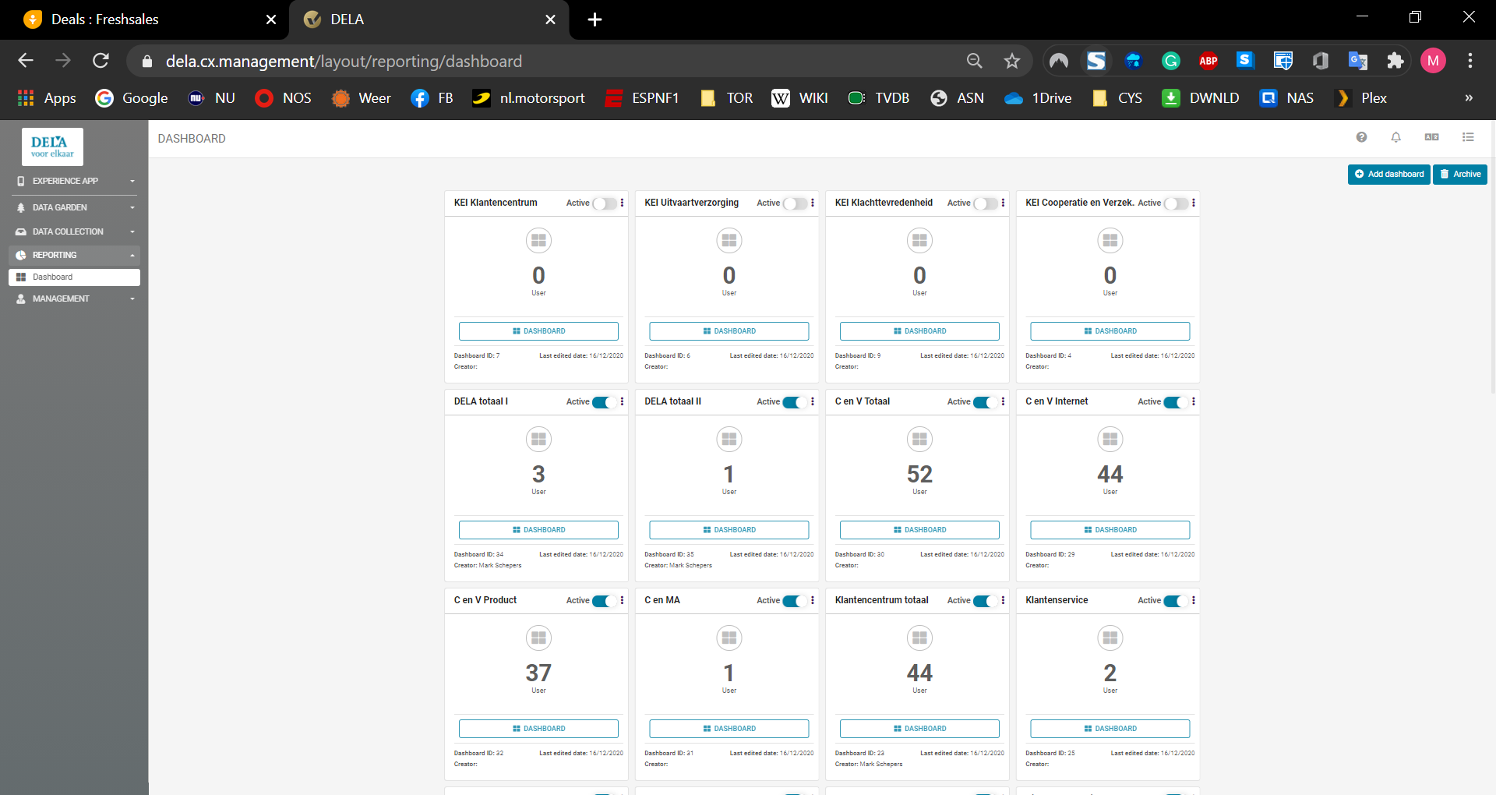

Pinning
Being able to pin up to a certain number of tiles so they always are on the same location when you login. The first 4 or 8 tiles could be reserved for Pinned tiles
See below an example of Wrike.
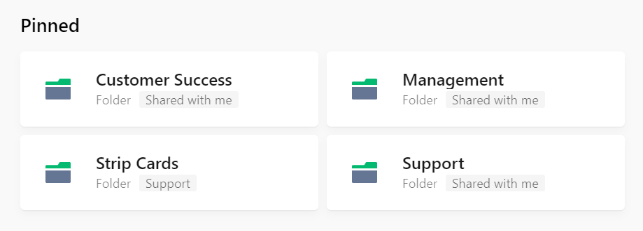

Recent
Reserve 2 rows of tiles that show the tiles that were most recently used (by the user), in order from most recent ion the top left to least recent bottom right.
In Wrike, the 4 most recent used folders are shown, clicking on the show more shows 20 additional folders and show more changes to show less.
A show all option should also be available.
