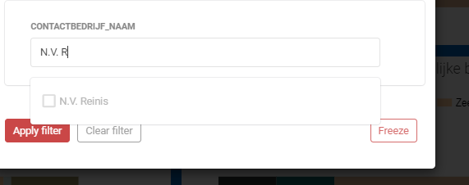

This Company can only be found when entering ‘N.V. R’ .
Ideally, just typing ‘reinis’ should have the same result.

